FAQ - General

Contents
What is Next Generation Desktop? 2
What computer will I receive? 2
How were computers assigned? 4
What monitor will I receive? 4
What software will I receive? 5
What if software I need is missing? 5
New Policies 5
How do I request software not on the Supported Software List? 6
When will I receive my computer? 6
How are computers being delivered? 6
How will my computer be replaced? 7
How do I get help? 7
What files do I need to move and where? 8
What is a Virtual PC? 8

What is Next Generation Desktop?

- Replace the District’s computers with one of the following:
    - New desktop with Office 2013/ Windows 7
    - New “virtual PC” (vPC) with Office 2013 /Windows 7 (see What is a Virtual PC?)
    - New laptops with Office 2013 / Windows 7

- Upgrade “back office” servers and software
- Implement initial network redesign and optimization changes
- Provide secure remote access for home, office and field workers (where possible)
- Ensure all Enterprise Resource Planning (ERP) applications are integrated and functioning as required

What computer will I receive?

In order to provide better service and a better computing experience, IT is setting standards for the computers that will be supported across the organization. These standards are based on the specifications needed for different types of computing use.
You will receive the computer and monitor identified during the needs assessment. We now have six types of computers and two monitor types. Also, some meeting rooms will have computers and projectors installed.

The following brand/models as our new standard supported computers:
Standard Desktop - HP EliteDesk 800 G1 (Ultra Slim Desktop) for basic applications such as Groupwise, Office, Internet and most of our corporate applications such as Tempest, Class and JD Edwards
- 3.4 Ghz Processor. 8MB cache, 4 core (8 threads)
- 8 GB memory
- 500 GB harddrive
- AMD Radeon 8490 1GB graphics card

Virtual PC - HP t310 Zero Thin Client is a combination of hardware and software that are an alternative to Standard Desktops and delivery improved support and lower costs.
- TERA2321 PCoIP processor
- 256 MB Flash drive

Power Desktop - HP Z230T for applications that require more powerful graphics performance, primarily ArcGIS Desk and Adobe Creative Suite.
- Intel® Xeon® processor, 3.4 GHz E3-1245v3, Quad-Core, 8 MB cache,
- 8 GB memory
- 500 GB harddrive
- AMD Firepro V3900 1GB graphics card

Hi Power Desktop - HP Z420 for the AutoDesk applications power users (not required for basic AutoDesk functions)
- Intel Xeon E5-1660 v2 processor. 3.7GHZ 15Mb cache, 6 Core; 1866Mhz CPU
- 32G memory
- 250 GB SSD drive
- Nvidia Quadro K2k 2GB PCI-e GFX

Standard Laptop - HP EliteBook 840 G1 with dock provides the same functions as a Standard Desktop in a laptop.
- Intel Core™ i5-4300U with Intel HD Graphics 4400 (1.9 GHz, 3 MB cache, 2 cores)
- 8G memory
- 320 GB hard drive

Power Laptop – HP ZBook 15 for laptop users who require more powerful graphics performance, primarily ArcGIS Desk and Adobe Creative Suite.
- Intel® Core™ i7-4800MQ with Intel HD Graphics 4600 (2.7 GHz, 6 MB cache, 4 cores)
- 16G memory
- 1 TB hard drive
Additional notes:
- There are some newer computers (less than 2 years old) that are not ?????
- New computers will have Windows 7 and Microsoft Office 2013
- Some Committee Rooms in the Hall, Annex and Public Works will also have a Computer and projector installed

How were computers assigned?

- Over the past three months, IT has completed a needs assessment to determine the type of computer everyone receives. This included completion of a needs assessment questionnaire and discussions with your managers.
- The majority of staff will be given either a Standard Desktop or a Virtual PC and experience very good performance. However, there are two considerations that may change the computer type you receive:
  - The software you use: some software such as Adobe InDesign or AutoCAD requires more powerful computers (Power or High Power Desktops)
  - Your need to have remote access: if you need to have a computer away from your desk or meeting room, a laptop is assigned (Standard or Power Laptop). [Note: we will have computers and projectors in Committee Rooms 1, 2 (Hall), 3, 4 (Annex) and Public Works (Yard)

What monitor will I receive?

Your monitor will be one of the following:
  - Standard monitors are 24” flat screen monitors
  - Exceptions will be made for those who need dual 24” monitors (primarily Power & Hi-Power clients) subject to supervisor approval.
  - Clients who prefer two 19” monitors will be given repurposed current monitors

What software will I receive?

In order to provide better service and a better computing experience IT has established a standardized Saanich Supported Software List which guides what software to be installed. Everyone will receive computers with all of the Standard Software. If you have a license or access privilege for the Specialized Software, that will be installed as well.

What if software I need is missing?
If you are missing software, please contact the HelpDesk.

New Policies

IT is establishing a list of Saanich supported software and is making some changes to how software is managed:

- IT must install software: you will no longer be able to install software on your computer. This will reduce the risk of viruses and data loss.
- Installed software: You will receive computers installed with all of the Standard Software (#1s) on the Saanich Supported Software List. Those with licenses or access privileges will receive Specialized Software (#2s).
- Requesting software: there is a new process for requesting software that is not on the Supported
- IT will be taking an active role in coordinating purchases of software and managing licenses. This will allow us to improve service by reducing the effort and cost to support so many different applications.

How do I request software not on the Supported Software List?
- Please contact IT Helpdesk. You will need to complete a form with a business case and a manager’s signature. IT will work with you to determine if any of the supported software meets your needs or if we can meet the technical or support needs.

When will I receive my computer?

- The roll out starts with a 2 week pilot in March where the new systems and computer configurations will be tested. Roll-out will begin shortly after this and will continue for about 4 months.
- Some groups seek August/September delivery.
- The plan for delivering computers and providing training is coordinated with each section to minimize disruption. It will be communicated directly to you as well as posted on our website.

How are computers being delivered?

The new computers will be delivered in a series of waves to different groups every day, according to the schedule, 10 computers per day. Training consultant, as well as IT staff will be available to provide support on site.
Before receiving your computer:
- The first step to transitioning will be to move all of the work-related information (documents, favourites, etc) from your current computer to a network drive.
(This process will reduce the risk of losing data stored on computer hard drives which are not backed up)
- More details and instructions will be provided

How will my computer be replaced?

On the day your new computer arrives, the following will happen:
- Mandatory Training: Each staff member will be scheduled into a training class at the Learning Centre about making the transition from Windows XP/Office 2003 to Windows 7 / Office 2013. While in the class, your old computer will be removed and replaced with the equipment identified in your needs assessment.
- Back at your desk: When you return, you will log in and follow a short checklist to get started with your new computer. IT assistance is available to help you if needed.

After receiving your computer
- You will use this new computer just as you do every day.
- If an issue arises, refer to the training and self-help materials. Should yu need an assistance, contact helpdesk and let them know.
- Some files need to be converted (old WordPerfect, etc.). Instructions and support will be provided.

How do I get help?

For any questions or issues not covered during training or on MyPC website, you can contact:
- IT staff who will be available in your area for about 1 hour after you return to your computer.
- Training consultant who will be available on site up to 2 hrs/day for drop-in sessions.
- Super Users will will serve as "Technology Guides" and help during the rollout to get you up and running.
- HelpDesk staff that have been trained to help resolve most of the issues.

- For more specific and advanced Office 2013 training there will be courses available through HR.

What files do I need to move and where?

- To come

What is a Virtual PC?
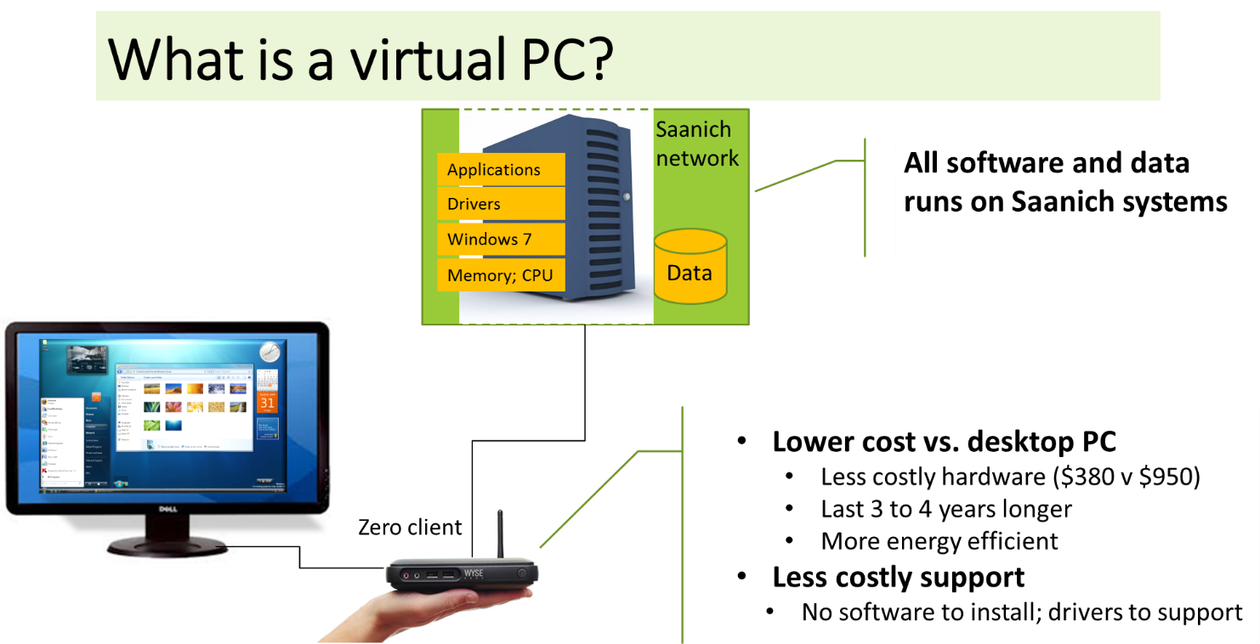

Virtual PCs are an alternative to the Standard Desktop and will be a growing part of Saanich’s computing strategy. This technology allows all of your software and data to run on powerful IT servers rather than the computer at your desk.
Virtual PCs will be delivered to a portion of staff as the first part of a transition to this new platform over several years. For staff, you will see or experience no real difference from a regular desktop computer.
Some of the key benefits will be:
- New vPCs provide a full Windows desktop. It will not require change from familiar desktop.
- Software is centrally managed and can be upgraded in a fraction of the time that traditional desktops would take.
- You can access your desktop from anywhere with an Internet connection.
- This technology dramatically increases security as data and applications are on the Saanich network.

See Appendix A - “What is the virtual PC?” for description

